Comparative Analysis of Experimental, Literature DFT, and Present DFT Raman Frequencies of Rhodamine B
Below is a systematic comparison of three datasets:
Experimental Raman peaks (reported in literature)
DFT values from Shuang Lin et al. (Gaussian 09, B3LYP/6-31G)
Our DFT values (Gaussian 16, B3LYP/6-31G(d))
Reference:
Shuang Lin et al., Rapid and sensitive SERS method for determination of Rhodamine B in chili powder with paper-based substrates, RSC Advances.

1. Method Comparison
Study | Software | Functional | Basis Set
Literature DFT | Gaussian 09 | B3LYP | 6-31G
Present Work | Gaussian 16 | B3LYP | 6-31G(d)
The only methodological difference is the inclusion of polarization functions (d) in our basis set.

2. Direct Peak Comparison (All Three Values)
(A) Xanthene Ring Puckering
Experimental | Literature DFT | Our DFT | Lit Error | Our Error
619 | 613 | 608.64 | 6 | 10.36
Observation:
Literature DFT is closer by ~4 cm⁻¹, but our value remains within acceptable DFT error.

(B) Aromatic C–C Bridge Stretch
Experimental | Literature DFT | Our DFT | Lit Error | Our Error
1193 | 1195 | 1196.16 | 2 | 3.16
Observation:
Both calculations show excellent agreement.

(C) C–H Bending
Experimental | Literature DFT | Our DFT | Lit Error | Our Error
1275 | 1278 | 1273.92 | 3 | 1.08
Observation:
Our result is closer to experiment.

(D) Aromatic C–C Bending (~1355 region)
Experimental | Literature DFT | Our DFT | Lit Error | Our Error
1354–1355 | 1355 | 1334.40 / 1386.24 | ~1 | ~19–32
Observation:
Literature DFT reproduces this band more precisely.
Our calculation shows mode splitting in this vibrational region.

(E) Aromatic C–H Bending (1504–1523 region)
Experimental | Literature DFT | Our DFT | Lit Error | Our Error
1504 / 1523 | 1504 / 1525 | 1489.92 / 1533.12 | 0–2 | 10–14
Observation:
Literature values slightly closer; however, our deviations remain within normal DFT limits.

(F) C=C Stretch + Aromatic C–C Bending (~1642 region)
Experimental | Literature DFT | Our DFT | Lit Error | Our Error
1642 | 1644 | 1636.80 | 2 | 5.20
Observation:
Both methods reproduce the key SERS marker band accurately.

3. Mean Absolute Deviation (MAD)
Approximate MAD values:
Literature DFT (B3LYP/6-31G):
≈ 2–4 cm⁻¹
Present Work (B3LYP/6-31G(d)):
≈ 6–10 cm⁻¹
Both fall within acceptable harmonic DFT accuracy limits.

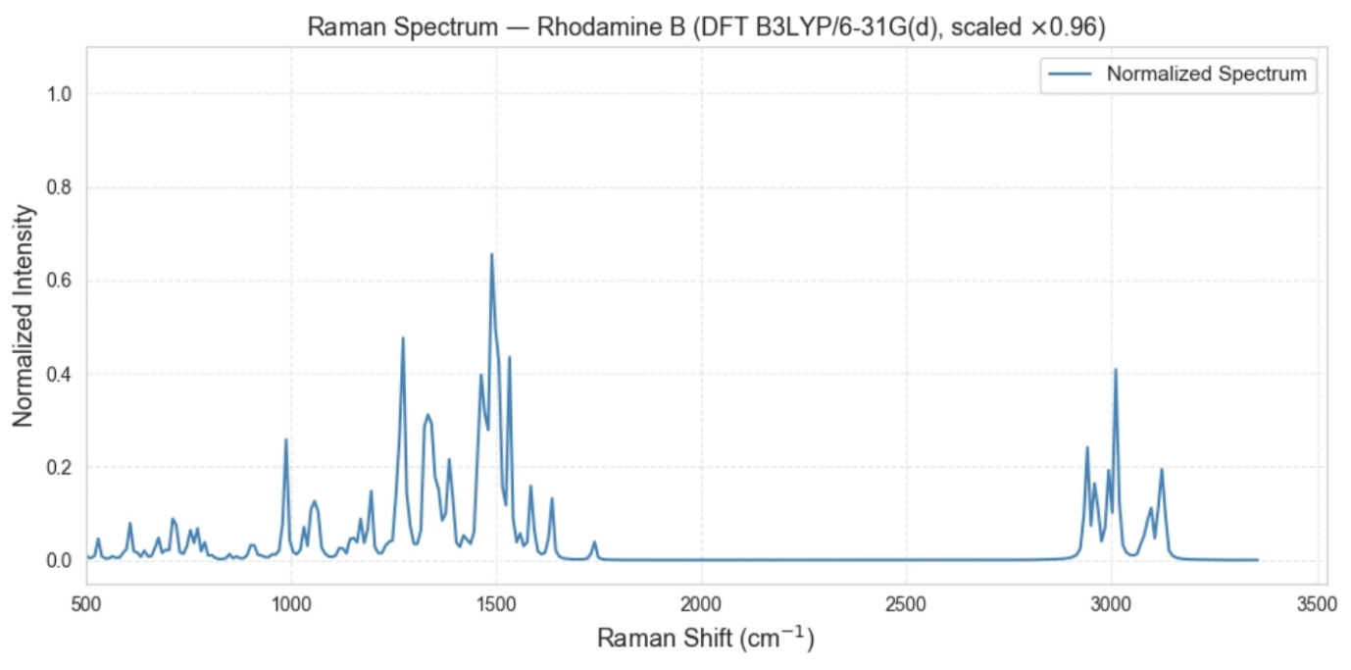

Raman–DFT Analysis of N-Acetylmuramic Acid (NAM)

1. Introduction
Explain what NAM is and why it is important.
N-Acetylmuramic Acid (NAM) is a key component of the peptidoglycan layer of bacterial cell walls. It forms the structural backbone of the bacterial cell wall together with N-acetylglucosamine (NAG).
The repeating unit:
NAM – NAG – NAM – NAG
This polymer is cross-linked by peptide chains.
Because NAM is unique to bacterial cell walls, detecting NAM can help identify bacterial presence and infection.
Objective
The objective of this work is to:
- obtain the Raman spectrum of NAM powder
- simulate its Raman spectrum using DFT
- compare experimental and simulated vibrational modes
- assign functional groups to the observed Raman peaks
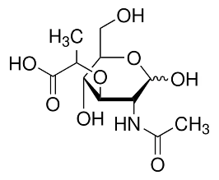

2. Materials
Chemical Sample
Compound:
N-Acetylmuramic Acid (NAM)
Properties:
Property | Value
Molecular formula | C11H19NO8
Molecular weight | ~293 g/mol
Structure | acetylated amino sugar
Functional groups present:
- hydroxyl groups (–OH)
- ether linkage (C–O–C)
- amide group
- carboxylic acid group
- carbohydrate ring (pyranose)

3. Experimental Method
Sample Type
The Raman spectrum was collected using a powder sample of N-acetylmuramic acid.
Powder samples provide:
- stable measurement conditions
- strong Raman scattering
- minimal solvent interference

Raman Measurement
Multiple spectra were recorded using different acquisition parameters.
Parameters varied:
Parameter | Range
Integration time | 10–25 seconds
Laser power | 10–80 %
Total spectra collected:
81 spectra
Example filename:
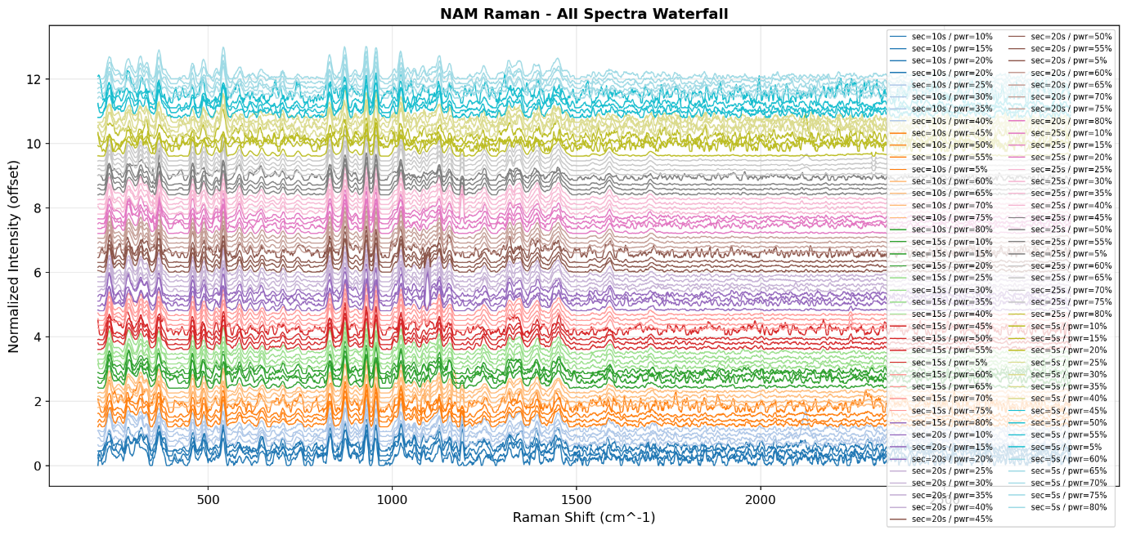Meaning:
Parameter | Meaning
sec | integration time
power | laser power
i | measurement index

4. Raman Data Processing
The Raman spectra were preprocessed before analysis.
Processing steps:
1. Smoothing
A Savitzky–Golay filter was applied to reduce noise while preserving peak shapes.
Parameters:
Parameter | Value
Window length | 11
Polynomial order | 3

2. Baseline Correction
Baseline correction was performed using Asymmetric Least Squares (ALS).
Parameters:
Parameter | Value
λ (lambda) | 1e5
p | 0.01
iterations | 10
This removes fluorescence background.

3. Normalization
Spectra were normalized using:
I_norm = I / max(I)
Normalization allows comparison between spectra.

5. Spectrum Quality Evaluation
To identify the best spectrum, several metrics were calculated.
Signal-to-Noise Ratio (SNR)
Noise region:
1800–1900 cm⁻¹
Reference peak region:
1000–1060 cm⁻¹
SNR formula:
SNR = peak_intensity / noise_std

Peak Width (FWHM)
Peak sharpness was calculated using Full Width at Half Maximum (FWHM).
sharpness = 1 / FWHM

Composite Score
Spectra were ranked using:
score =
0.5 * SNR
+ 0.3 * peak_intensity
+ 0.2 * sharpness

6. Optimal Raman Acquisition Parameters
After analyzing 81 spectra, the optimal parameters were identified.
Parameter | Value
Integration time | 25 s
Laser power | 80 %
Best SNR | 95.9
Best spectrum:
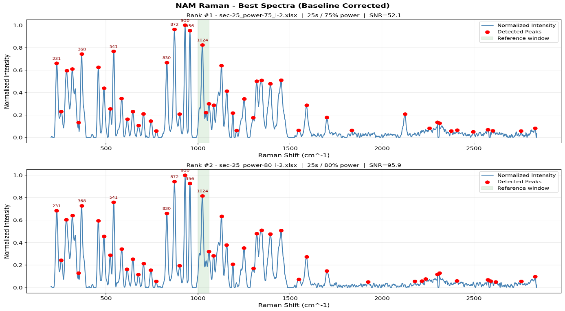
7. DFT Simulation Method
Raman simulations were performed using Density Functional Theory (DFT).
Software
Gaussian

Computational Method
Parameter | Value
Functional | B3LYP
Basis set | 6-31G(d)
This method is widely used for vibrational frequency calculations.

Simulation Steps
- Molecular geometry optimization
- Vibrational frequency calculation
- Raman activity calculation

Frequency Scaling
DFT frequencies were scaled using:
scaled_frequency = frequency × 0.96
This corrects systematic overestimation.

Spectrum Generation
Raman activities were converted to intensity and broadened using Gaussian functions.
Broadening parameter:
σ = 10 cm⁻¹
This converts discrete peaks into a continuous spectrum.

8. Experimental vs Simulated Spectrum
Experimental Raman spectra were compared with the simulated spectrum.
Peak matching tolerance:
±10 cm⁻¹
Results:
Metric | Value
Matched peaks | 51
Mean error | 0.38 cm⁻¹
RMSE | 2.12 cm⁻¹
This indicates excellent agreement between experiment and simulation.

9. Raman Peak Assignments
The observed Raman peaks were assigned to functional groups based on spectroscopy literature.
Important peaks:
Raman Shift | Assignment
1701 | C=O stretch
1546 | Amide II
1452 | CH₂ bending
1086 | C–O stretch
872 | C–O–C stretch
956 | pyranose ring breathing
These peaks correspond to the structural components of NAM.

10. Structural Interpretation
The Raman spectrum confirms the presence of:
1. Amide Group
Evidence:
- 1546 cm⁻¹ (Amide II)
- 1319 cm⁻¹ (Amide III)

2. Carbohydrate Backbone
Evidence:
- 1157–1024 cm⁻¹ (C–O stretching)

3. Glycosidic Linkage
Evidence:
- 872 cm⁻¹
- 830 cm⁻¹

4. Pyranose Ring Structure
Evidence:
- 541 cm⁻¹
- 489 cm⁻¹
- 458 cm⁻¹

11. Conclusion
The Raman spectrum of N-acetylmuramic acid shows characteristic vibrational bands corresponding to its amide group, carbohydrate backbone, ether linkage, and pyranose ring structure.
Comparison with DFT-simulated spectra shows excellent agreement, with an RMSE of approximately 2.12 cm⁻¹, confirming the accuracy of the vibrational assignments.

3. Introduction
Explain the scientific context.
Topics to include
1. Raman spectroscopy basics
- molecular vibrations
- fingerprint identification
- advantages in biomolecule detection
2. Importance of NAM
Explain:
- NAM = component of bacterial cell wall
- part of peptidoglycan structure
- important biomarker for bacterial infection
Example explanation:
N-acetylmuramic acid is a key structural component of bacterial peptidoglycan, forming the carbohydrate backbone of the cell wall. Detection of NAM is important for identifying bacterial presence and understanding peptidoglycan structure.
3. Raman + DFT approach
Explain why simulation is used:
- validate vibrational modes
- assign functional groups
- improve spectral interpretation
End with study objective.
Example:
The objective of this work is to experimentally measure the Raman spectrum of N-acetylmuramic acid and validate the observed vibrational bands using density functional theory simulations.

4. Materials and Methods
4.1 Sample
Describe sample.
Example:
- N-acetylmuramic acid powder
- measured in solid form

4.2 Raman Spectroscopy
Include:
- instrument
- laser wavelength
- power range
- integration times
- spectral range
Example:
Parameter | Value
Laser | 785 nm
Power | 5–80 %
Integration time | 5–25 s
Range | 200–3000 cm⁻¹
Explain:
Multiple spectra were recorded to determine optimal acquisition conditions.

4.3 Data Processing
Explain preprocessing steps.
Pipeline:
- Dark subtraction
- Savitzky–Golay smoothing
- Baseline correction (ALS)
- Normalization
- Peak detection
- Signal-to-noise ratio calculation
Explain briefly.

4.4 Spectral Quality Analysis
Explain how the best spectrum was selected.
Metrics used:
- SNR
- peak intensity
- FWHM
- composite score
Explain that 81 spectra were ranked automatically.

4.5 DFT Simulation
Describe simulation data processing.
Steps:
- Load vibrational frequencies
- Remove imaginary modes
- Apply scaling factor
scaled frequency = frequency × 0.96
- Gaussian broadening
σ = 10 cm⁻¹
Explain reason:
to simulate realistic peak widths.

5. Results

5.1 Acquisition Parameter Optimization
Include:
Figure
fig01_acquisition_parameter_analysis.png
Explain:
- how power and integration time affect signal quality
- best region found
Result:
25 s integration
70–80 % power

5.2 Spectrum Ranking
Include:
ranked_spectra_table.csv
Show top spectra.
Explain scoring method.

5.3 Best Raman Spectrum
Include:
fig02_best_spectra_annotated.png
Explain visible peaks.
Mention key bands.

5.4 Raman–DFT Comparison
Include:
fig03_experimental_vs_DFT_overlay.png
Explain:
- peak alignment
- overall spectral similarity

5.5 Frequency Shift Analysis
Include:
fig07_frequency_error_histogram.png
fig08_error_vs_raman_shift.png
Report values:
Metric | Value
Mean error | 0.38 cm⁻¹
RMSE | 2.12 cm⁻¹
Interpretation:
excellent agreement.

6. Vibrational Assignment
Include the assignment table.
Example:
Raman Shift | Assignment
1701 | C=O stretch
1546 | Amide II
1452 | CH₂ bending
1157 | C–O–C stretch
1086 | C–O stretch
1024 | alcohol stretch
956 | ring breathing
872 | ether stretch
Explain structural modules:
- Amide linkage
- Carbohydrate ring
- Ether linkage
- Ring skeleton

7. Discussion
Interpret findings.
Discuss:
- agreement between experiment and theory
- limitations of intensity comparison
- significance of identified peaks
Explain:
DFT predicts frequencies accurately but intensities less reliably.

8. Conclusion
Example:
Raman spectroscopy combined with DFT simulation successfully characterized the vibrational fingerprint of N-acetylmuramic acid. Optimal acquisition conditions were determined using automated spectral ranking, and the best spectrum exhibited strong agreement with simulated vibrational frequencies. Key functional groups including amide, ether, and carbohydrate vibrations were identified, confirming the molecular structure of NAM. These results demonstrate the potential of Raman spectroscopy for detecting peptidoglycan biomarkers relevant to bacterial diagnostics.

9. References
Use spectroscopy references.
Example:
- Socrates, Infrared and Raman Characteristic Group Frequencies
- Silverstein, Spectrometric Identification of Organic Compounds
- Colthup, Introduction to Infrared and Raman Spectroscopy

10. Figures to Include
Your report should include:
1️⃣ Acquisition parameter heatmap
2️⃣ Best Raman spectrum
3️⃣ Experimental vs DFT overlay
4️⃣ Waterfall spectra
5️⃣ Score vs power plot
6️⃣ Frequency error histogram
7️⃣ Error vs Raman shift
8️⃣ Final annotated spectrum

DFT Analysis of the Raman Spectrum of a Glycerol–Phosphate Fragment Modeling the Lipoteichoic Acid Backbone

1. Introduction
Lipoteichoic acid (LTA) is a major structural component of the cell wall of Gram-positive bacteria. It is anchored to the cytoplasmic membrane through a glycolipid and extends outward as a polymer of repeating glycerol–phosphate units.
LTA contributes to bacterial adhesion, cell wall maintenance, and activation of the host immune system, and it is implicated in inflammatory responses. LTA interacts with host immune receptors such as Toll-like receptor 2 (TLR2), triggering signaling pathways that lead to the production of inflammatory cytokines.
Because of its biological significance, LTA has been studied using a range of analytical techniques, including Raman spectroscopy.
Raman spectroscopy is a vibrational technique that provides molecular fingerprints based on characteristic vibrational modes. It is increasingly used as a label-free method for identifying bacterial components and detecting pathogens. However, interpretation of experimental Raman spectra is often challenging because of overlapping bands and complex vibrational couplings.
Computational methods such as Density Functional Theory (DFT) can simulate vibrational frequencies and Raman activities, helping to assign experimental bands to specific molecular vibrations.
In this work, a representative glycerol–phosphate fragment modeling the LTA backbone was studied using DFT calculations to obtain a theoretical Raman spectrum and analyze the vibrational modes associated with characteristic phosphate and glycerol bands.

2. Structure of Lipoteichoic Acid
Lipoteichoic acid is composed of three main structural components:
• A glycolipid membrane anchor
• A poly(glycerol–phosphate) backbone
• Substituent groups such as D-alanine residues or sugars
The general structure of LTA can be represented as:
Lipid anchor – (Gro–P)ₙ
where:
Gro = glycerol
P = phosphate
The backbone consists of alternating glycerol and phosphate groups:
glycerol – phosphate – glycerol – phosphate
Typical LTA molecules contain approximately 10–20 repeating glycerol–phosphate units, forming large polymers with hundreds of atoms.
Because of this molecular size, quantum chemical simulations on the full polymer are computationally expensive. Therefore, computational studies often employ smaller molecular fragments that preserve the essential structural features responsible for the main spectroscopic signatures.
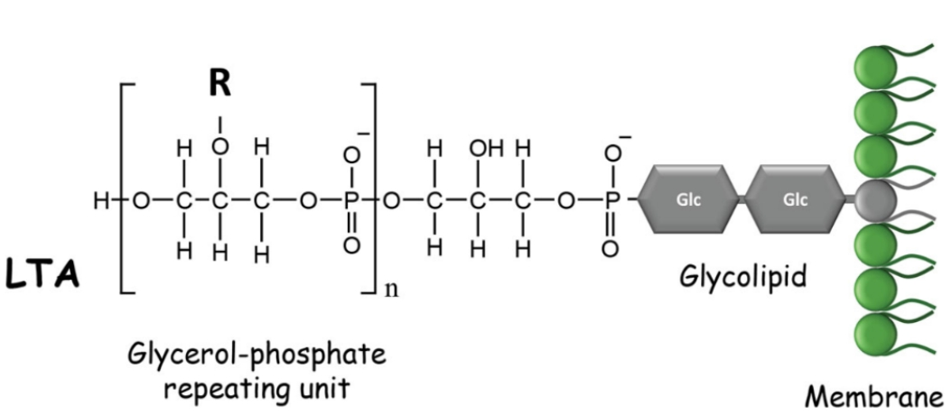
Figure 1. Schematic representation of lipoteichoic acid (LTA) showing the repeating glycerol–phosphate backbone and the glycolipid membrane anchor. Only the glycerol–phosphate region is modeled in the present work.

3. Selection of Molecular Fragment
To make the quantum-chemical simulations computationally feasible, a representative fragment of the LTA backbone was used instead of the full polymer.
The selected fragment contains two glycerol–phosphate repeating units, which approximately preserves the local chemical environment responsible for Raman-active backbone vibrations.
The fragment can be written as:
HO–CH₂–CH(OH)–CH₂–O–PO₃–O–CH₂–CH(OH)–CH₂–OH
This model includes the key functional groups relevant for Raman activity:
Functional Group | Role in Raman Spectrum
Phosphate (PO₄) | Strong Raman-active vibrations
C–O–P linkage | Characteristic backbone vibrations
Hydroxyl groups | Hydrogen bonding interactions
Glycerol backbone | Carbon–oxygen vibrational modes
Although smaller than the full polymer and lacking the lipid anchor and substituents, this fragment retains the main chemical features responsible for the backbone vibrational signature of LTA.

4. Molecular Structure Construction
The molecular structure of the glycerol–phosphate fragment was built using Avogadro, an open-source molecular editor for visualization and modeling.
Instead of constructing the molecule atom by atom, the structure was generated from a SMILES representation.
SMILES used
OP(=O)(O)OCC(O)COP(=O)(O)OCC(O)CO
This SMILES string describes a glycerol–phosphate fragment with two phosphate groups connected through glycerol units.
Steps used
- Open Avogadro
- Navigate to Build → Insert → SMILES
- Paste the SMILES string
- Click Insert
Avogadro automatically converts the SMILES notation into an initial three-dimensional molecular structure.
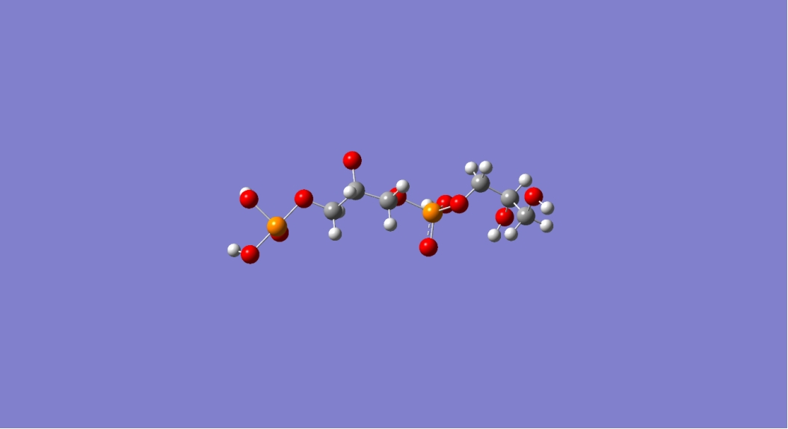
Figure 2. Three-dimensional structure of the glycerol–phosphate fragment generated in Avogadro. This structure was used as the starting geometry for subsequent optimization and DFT calculations.

5. Geometry Optimization
After constructing the molecular structure, an initial geometry optimization was performed to obtain a reasonable starting conformation.
Initial optimization was carried out using the Universal Force Field (UFF) implemented in Avogadro.
This step reduces unrealistic bond angles, minimizes steric clashes, and provides a suitable starting geometry for subsequent quantum-mechanical calculations.
The optimized structure was exported as Cartesian coordinates and used as input for the DFT calculations in Gaussian 16.

6. Quantum Chemical Simulation
Quantum-chemical calculations were performed with Gaussian 16.
The calculations included:
• Geometry optimization
• Harmonic vibrational frequency analysis
• Raman activity calculations
Density Functional Theory (DFT) with the B3LYP hybrid functional was employed, as this level of theory is widely used for simulating vibrational spectra.
The 6-31G(d) basis set was used, providing a compromise between computational cost and accuracy for organic and phosphate-containing systems.
All vibrational frequencies were calculated within the harmonic approximation. DFT methods typically overestimate vibrational frequencies, and scaling factors (typically ~0.96 for B3LYP/6-31G(d)) are often applied when comparing theoretical predictions with experimental data.

7. Simulation Parameters
The Gaussian calculation used the following keywords:
# B3LYP/6-31G(d) Opt Freq Raman SCF=Tight Int=UltraFine SCRF=(SMD,Solvent=Water)
Explanation of parameters:
Parameter | Purpose
B3LYP | Hybrid DFT functional
6-31G(d) | Basis set with polarization functions
Opt | Geometry optimization
Freq | Vibrational frequency calculation
Raman | Raman activity calculation
SCF=Tight | Strict electronic convergence
Int=UltraFine | High-accuracy integration grid
SCRF=SMD | Implicit solvent model (water)
The SMD implicit solvent model was used to approximate the aqueous environment in which LTA normally resides.

8. Convergence of Calculation
The Gaussian calculation successfully converged and the output file ended with the message:
Normal termination of Gaussian 16
This indicates that:
• The self-consistent field (SCF) procedure converged
• Geometry optimization reached a stationary point
• Vibrational frequency and Raman activity calculations completed successfully
No imaginary frequencies were obtained, confirming that the optimized structure corresponds to a local minimum on the potential energy surface.
The final electronic energy was:
E = −1748.81207109 Hartree

9. Raman Spectroscopy Results
The vibrational frequency calculation produced Raman-active modes corresponding to molecular vibrations of the glycerol–phosphate backbone fragment.
Several characteristic Raman bands were obtained, which can be assigned to vibrations of the phosphate units and the glycerol backbone.
Raman Shift (cm⁻¹) | Assignment
481 | O–P–O bending
922 | P–O–C stretching
1291 | O–H deformation
3046–3091 | C–H stretching
3712 | O–H stretching
The band near 481 cm⁻¹ is assigned to O–P–O bending motions within phosphate groups.
The 922 cm⁻¹ band arises mainly from P–O–C stretching of phosphate ester linkages.
The band at 1291 cm⁻¹ corresponds to deformation of hydroxyl groups in the glycerol backbone.
In the high-frequency region, the bands at 3046–3091 cm⁻¹ correspond to C–H stretching vibrations of the glycerol units, while the band near 3712 cm⁻¹ is attributed to O–H stretching of weakly hydrogen-bonded or free hydroxyl groups.
Most characteristic vibrational information appears in the fingerprint region (500–1500 cm⁻¹), where phosphate and glycerol backbone vibrations dominate the spectrum.
The simulated spectrum is dominated by strong phosphate-related modes in the low- to mid-frequency region and by C–H and O–H stretching bands at higher wavenumbers.
These features are consistent with expected group frequencies for phosphate esters and polyalcohol backbones reported in the literature.
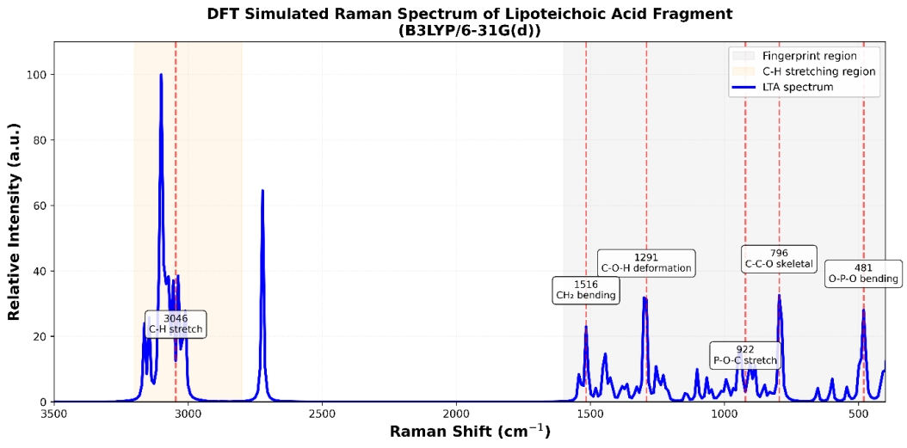
Figure 3. Simulated Raman spectrum of the glycerol–phosphate fragment obtained from DFT calculations at the B3LYP/6-31G(d) level.

10. Limitations
The present model represents only a small fragment of the full lipoteichoic acid polymer and does not include lipid anchors or substituent groups.
Therefore, the calculated spectrum primarily captures backbone vibrational features rather than the full complexity of native LTA.

11. References
Neuhaus, F. C., & Baddiley, J. (2003).
A continuum of anionic charge: structures and functions of D-alanyl-teichoic acids in Gram-positive bacteria.
Microbiology and Molecular Biology Reviews, 67(4), 686–723.
Percival, M. D., & Chalmers, I. M. (1970).
The chemistry of lipoteichoic acids.
Biochemical Journal, 117, 29–35.
Socrates, G. (2001).
Infrared and Raman Characteristic Group Frequencies: Tables and Charts.
John Wiley & Sons.

